**PICTA Style Guide**

**Contents**

Asthma Control Test Pamphlet Interior, English

Asthma Control Test Pamphlet Front and Back Covers, English

Asthma Control Test Pamphlet Interior, Spanish

Asthma Control Test Pamphlet Front and Back Covers, Spanish

Adult Pulmonary Function Test Pamphlet Interior, English

Adult Pulmonary Function Test Pamphlet Front and Back Covers, English

Adult Pulmonary Function Test Pamphlet Interior, Spanish

Adult Pulmonary Function Test Pamphlet Front and Back Covers, Spanish

Fonts: Arial, Arial Bold, Arial Narrow, Arial Narrow Bold

**Asthma Control Test Pamphlet Interior, English**

Variables: Patient name, today’s ACT score and date, [previous ACT score and date]

Units: Whole numbers

Tailoring: Patient’s name, interpretive statement, score statement, progress statement, if applicable, today’s score, previous score and date if available, and today’s date.

Criteria: 5-15 is ‘very poorly controlled’, 16-19 is ‘not well controlled’, 20-25 is ‘well controlled’. A difference of 3 or more points is considered clinically meaningful. Although scores 0-4 are not possible, they are shown because a scale that starts at 0 is more intuitive.

Colors: Main text color is black. If there is a previous score, the associated text and arrows are 50% gray (#939598). Numbers along the bottom of the number line are 75% gray (#636466). Text inside number line is white, with a black drop shadow. Gradient goes from dark red (#891924) at left to medium red (#BE1E2D), orange (#F15A29), yellow-orange (#F7941D), lime green (#8DC63F), to green (#00A651) at right.

Text specs: *Title* at upper left is 12pt Arial Bold, all caps, flush with left margin (0.5”).

*Date* is 14pt Arial, flush with the right (0.5”) and bottom (0.5”) margins.

The following text block should be centered vertically between the title and the tops of the people’s heads:

*Interpretive statement* is 22pt Arial Bold, indented 0.75” from left margin, no punctuation at the end. Options, based on above criteria, are:

* “Your asthma is very poorly controlled”
* “Your asthma is not well controlled”
* “Your asthma is well controlled”

*Score statement* is 22pt Arial, flush left with interpretive statement, no punctuation. If there is only one score, it comes immediately below the interpretive statement, single spaced. If there are two scores, leave a space equivalent to one line of text between the interpretive statement and the score statement.

*Progress statement* (if two scores are available) is 22 pt. Arial, flush left with the statements above it, and has punctuation at the end. Options are:

* “It has gotten worse since your last visit.” if today’s score is 3 or more units lower than the previous score.
* “It is about the same as at your last visit.” if today’s score is 19 or less and the difference between scores is 2 units or less.
* Omit the progress statement if the score is 20 or higher and today’s score is greater than or equal to the previous score, or no more than 2 units lower than the previous score.
* “You made good progress!” if the score is 19 or less and 3 or more units higher than the previous score.
* “Great job!” If today’s score is 20 or higher and the previous score was 19 or lower.

**Examples:**

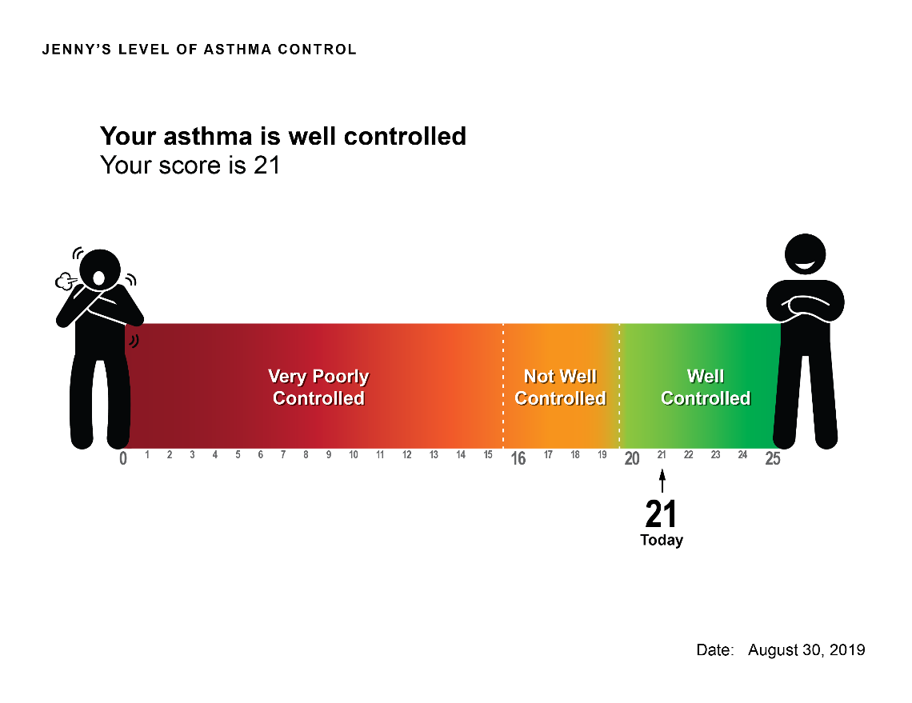

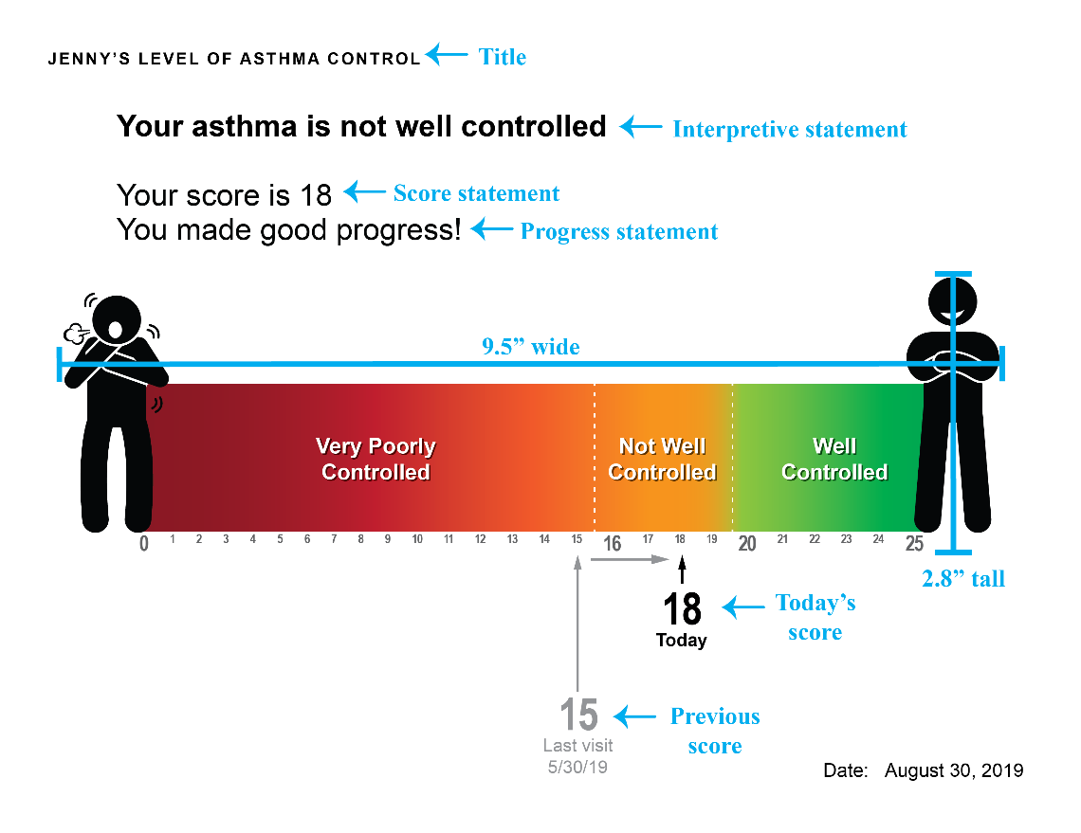

**Asthma Control Test Pamphlet Front and Back Covers, English**

No tailoring. Image will be provided. When printing double-sided, flip on short edge for images to align properly.

Example:

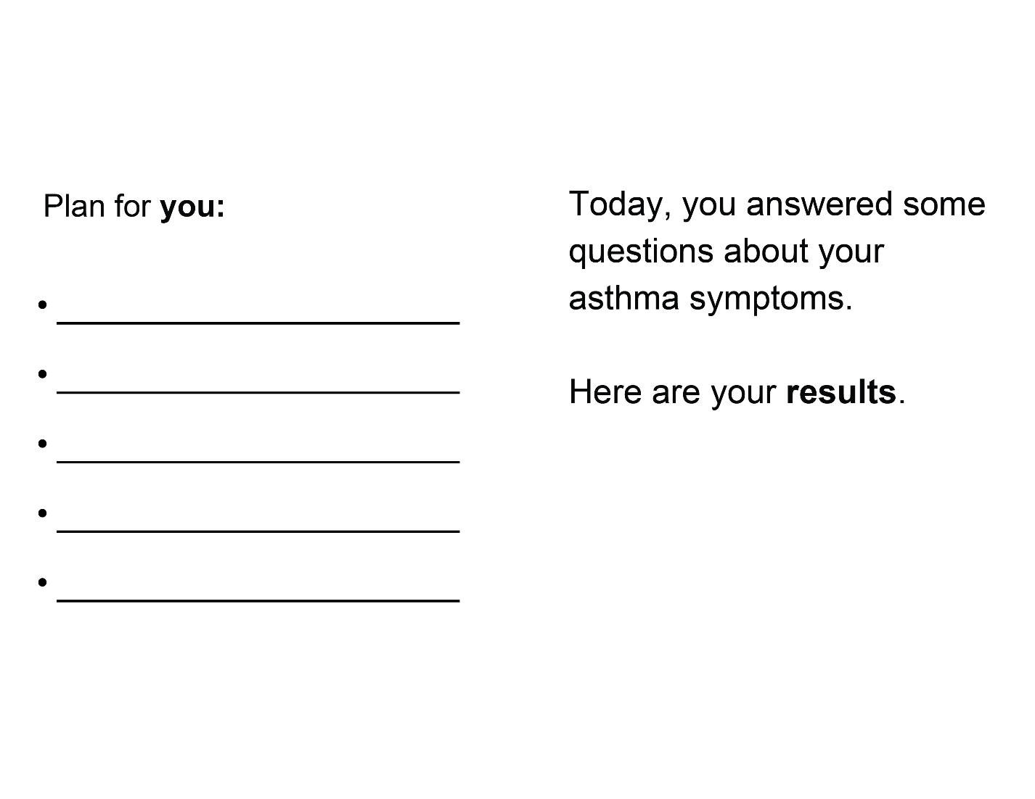

**Asthma Control Test Pamphlet Interior, Spanish**

Variables: Patient name, today’s ACT score and date, [previous ACT score and date]

Units: Whole numbers

Tailoring: Patient’s name, interpretive statement, score statement, progress statement, if applicable, today’s score, previous score and date if available, and today’s date.

Criteria: 5-15 is ‘muy mal controlada’, 16-19 is ‘mal controlada’, 20-25 is ‘bien controlada’. A difference of 3 or more points is considered clinically meaningful. Although scores 0-4 are not possible, they are shown because a scale that starts at 0 is more intuitive.

Colors: Main text color is black. If there is a previous score, the associated text and arrows are 50% gray (#939598). Numbers along the bottom of the number line are 75% gray (#636466). Text inside number line is white, with a black drop shadow. Gradient goes from dark red (#891924) at left to medium red (#BE1E2D), orange (#F15A29), yellow-orange (#F7941D), lime green (#8DC63F), to green (#00A651) at right.

Text specs: *Title* at upper left is 12pt Arial Bold, all caps, flush with left margin (0.5”).

*Date* is 14pt Arial, flush with the right (0.5”) and bottom (0.5”) margins. Note that the format is: XX of month, year (“30 de agosto, 2019). Months are not capitalized:

|  |  |  |  |  |
| --- | --- | --- | --- | --- |
| January | enero |  | July | julio |
| February | febrero |  | August | agosto |
| March | marzo |  | September | septiembre |
| April | abril |  | October | octubre |
| May | mayo |  | November | noviembre |
| June | junio |  | December | diciembre |

The following text block should be centered vertically between the title and the tops of the people’s heads:

*Interpretive statement* is 22pt Arial Bold, indented 0.75” from left margin, no punctuation at the end. Options, based on above criteria, are:

* “Su asma está muy mal controlada” (very poorly controlled)
* “Su asma está mal controlada” (not well controlled)
* “Su asma está bien controlada” (well controlled)

*Score statement* is 22pt Arial, flush left with interpretive statement, no punctuation (“Su puntaje es XX”). If there is only one score, it comes immediately below the interpretive statement, single spaced. If there are two scores, leave a space equivalent to one line of text between the interpretive statement and the score statement.

*Progress statement* (if two scores are available) is 22 pt. Arial, flush left with the statements above it, and has punctuation at the end. Options are:

* “Ha empeorado desde su última visita.” if today’s score is 3 or more units lower than the previous score.
* “Sigue igual que desde su última visita.” if today’s score is 19 or less and the difference between scores is 2 units or less.
* Omit the progress statement if the score is 20 or higher and today’s score is greater than or equal to the previous score, or no more than 2 units lower than the previous score.
* “Ha habido mejora!” if the score is 19 or less and 3 or more units higher than the previous score.
* “Muy bien!” If today’s score is 20 or higher and the previous score was 19 or lower.

**Example:**

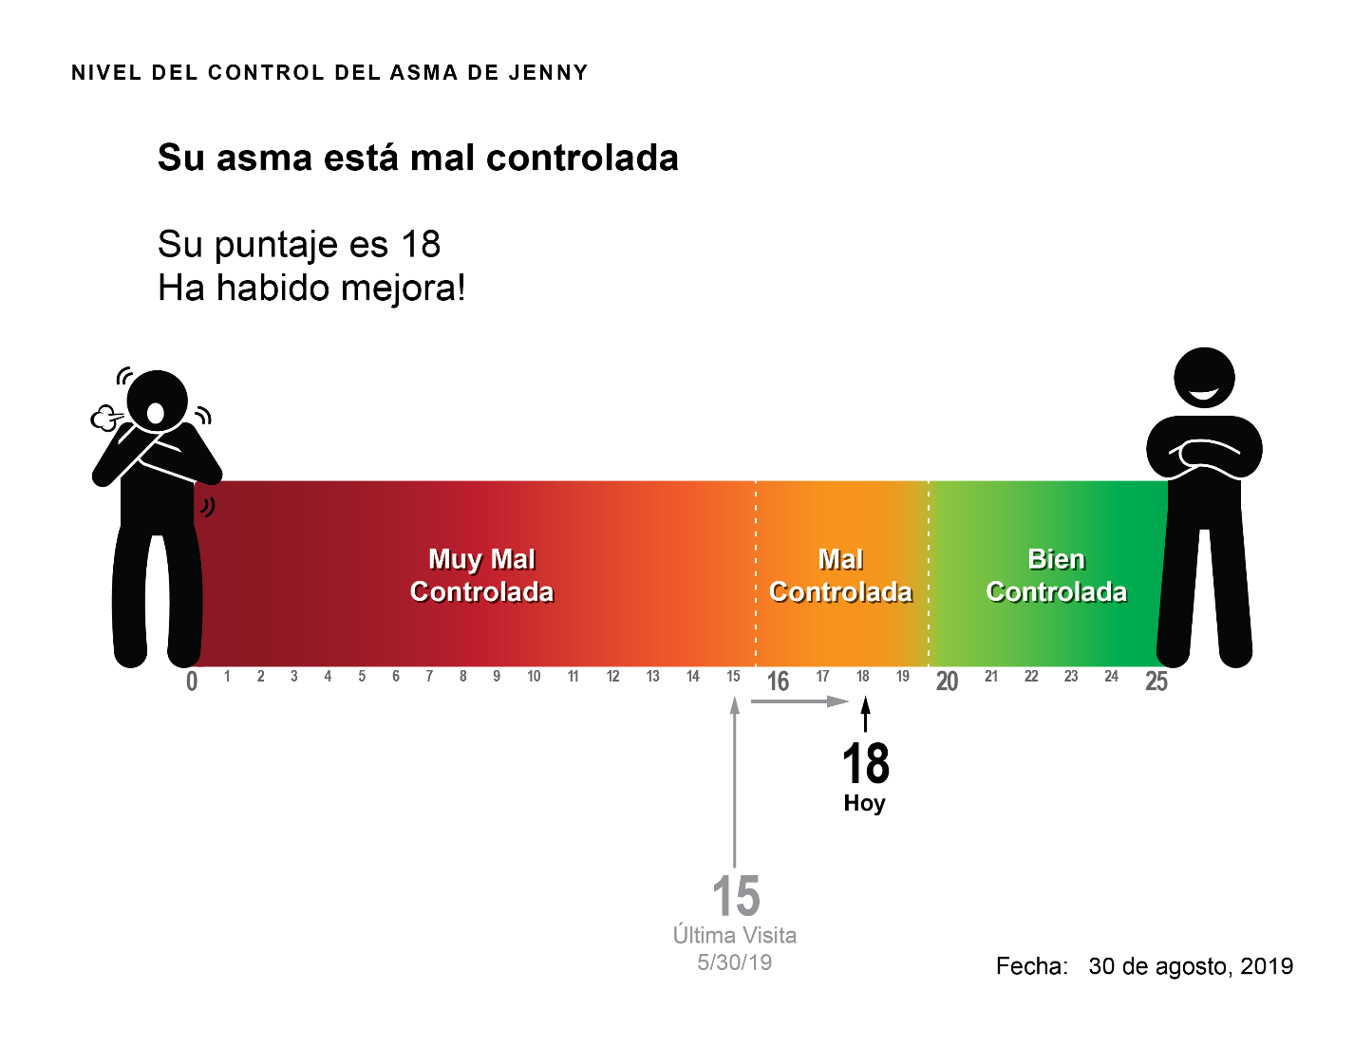

**Asthma Control Test Pamphlet Front and Back Covers, Spanish**

No tailoring. Image will be provided. When printing double-sided, flip on short edge for images to align properly.

Example:

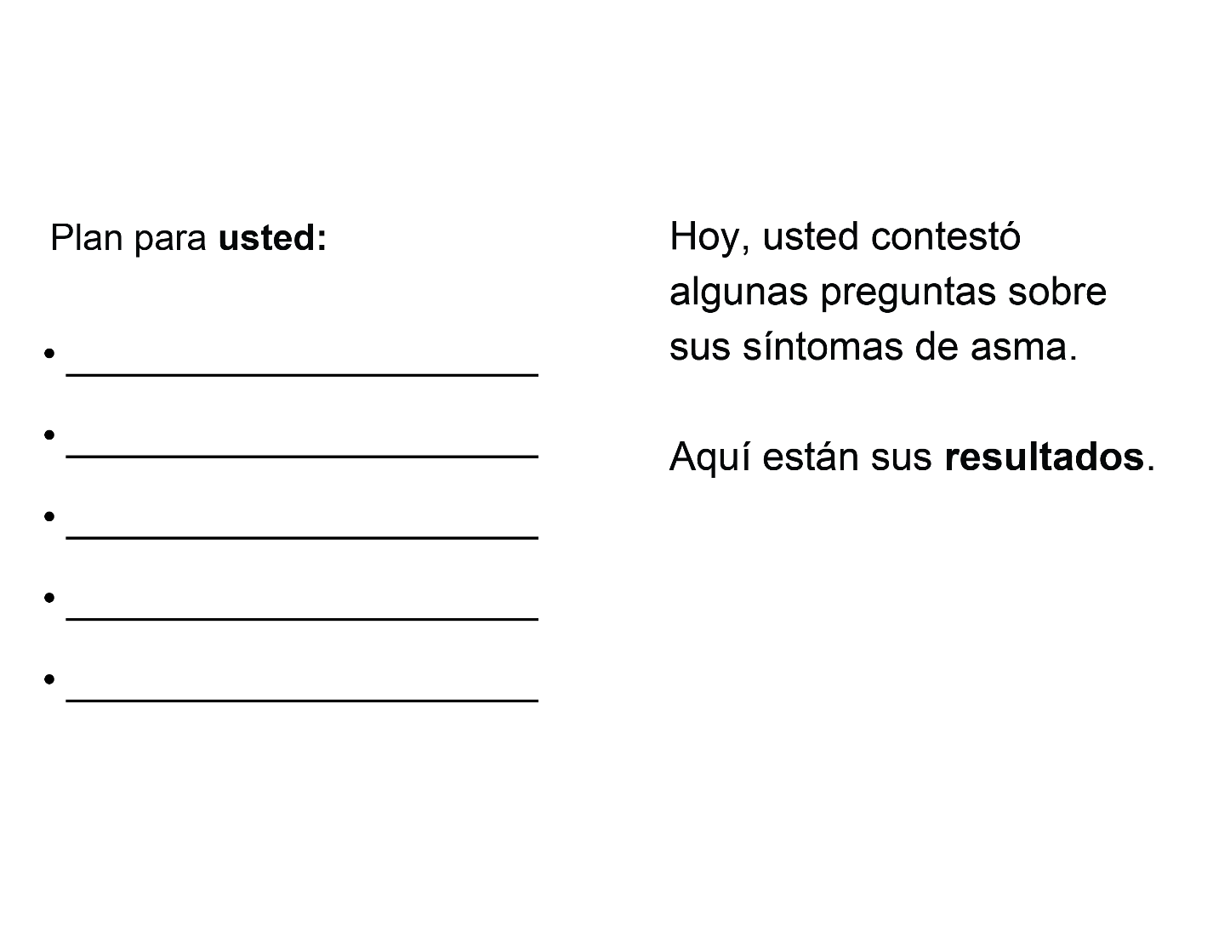

**Adult Pulmonary Function Test Pamphlet Interior, English**